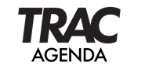 DES MOINES AREA REGIONAL TRANSIT AUTHORITY
TRANSIT RIDERS ADVISORY COMMITTEE
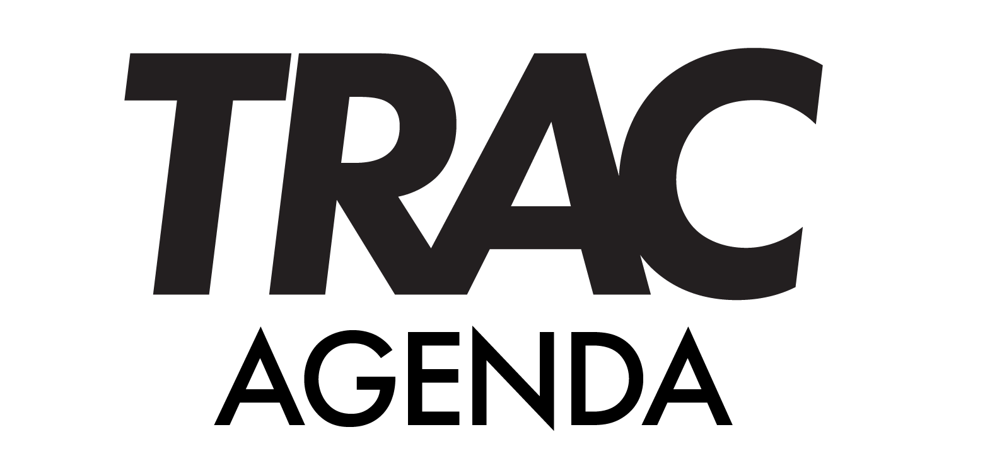
JANUARY 22, 2025 – noon

Zoom Log In
Join Zoom Meeting
https://ridedart.zoom.us/j/88900305025?pwd=IgtD30JbDbzfL6OadAabAM0QlPDSza.1

Meeting ID: 889 0030 5025
Passcode: 195220

ROLL CALL AND ESTABLISHMENT OF QUORUM

- APPROVAL OF DECEMBER 18, 2024, MINUTES
- PUBLIC COMMENT
- NEW MEMBER INTRODUCTION
  - Alexis Samano
- TRAC CHAIR VOTE
- DISCUSSION ITEMS
  - Reimagine DART Update (Erin)
- OTHER BUSINESS
- TRAC MEMBER COMMUNICATIONS
- FUTURE AGENDA ITEMS
  - On Time Performance Discussion
  - Mobility Servies Updates
  - FY26 Budget Update
- UPCOMING MEETINGS
  - DART Commission – Noon Tuesday, January 28, 2025, Zoom / DCS
  - TRAC – Noon Wednesday, February 26, 2025, Zoom / DCS
- ADJOURN

